FORM: SAF-BIL-00-18

Effective: January 03, 2018

**Society of Philippine Electrotechnical Constructors & Suppliers, Inc.**

🖂 2/F IIEE Bldg., No. 41 Monte de Piedad St., Cubao, Quezon City, Philippines 1111 🕾🖷: 63(02) 722-4725; 413-0994 ⦁ : [specsphils.68@gmail.com](mailto:specsphils.68@gmail.com) : [www.specs.org.ph](http://www.specs.org.ph)



June 24, 2019

Dear Sir/Madam,

The Society of Philippine Electrotechnical Constructors and Suppliers, Inc. (SPECS) will hold its**Fun Game Bowling Tournament** at Superbowl, 3rd Floor Makati Cinema Square, Pasong Tamo, Makati City, 12:30 p.m. as part of promoting camaraderie among the members and friends of SPECS.

In this regard, we would like to invite your company to assist SPECS in holding these tournament through **SPONSORSHIP** at a package rate of **Php 5,000.00/event**. This will entitle your company to:

1. One Playing Team; Free of Charge
2. Company name/logo inclusion in the streamer which will be displayed at the bowling center during the tournament.
3. Company name/logo inclusion in the event’s program.
4. Distribution of promotional materials during the tournament.
5. Acknowledgement in the SPECS Magazine.

Please (/)Check your preferred Schedule:

* July 27, 2019 – 37th SPECS Fun Game Bowling Tournament
* October 26, 2019 – 38th SPECS Fun Game Bowling Tournament

We believe, your worthy contribution will surely contribute to the success of these sports events. Please confirm your participation by signing the conforme space provided below and email it back to the Secretariat through Email Address: specsphils.68@gmail.com. For more details, feel free to call the SPECS Secretariat and we will be glad to assist you.

Thank you very much in anticipation of your favorable response.

Very truly yours,

Society of Philippine Electrotechnical

Constructors & Suppliers, Inc.



**ARTURO P. CENAL Conforme:**

Chairman, SPECS

Chairman, Sports & Fellowship Commit tee

Bowling Organizing Sub-Committee _______________________________

**SIGNATURE OVER PRINTED NAME**

**Philippine Constructors**

**Association**

**Federation of Asian and Pacific Electrical Contractors Associations**

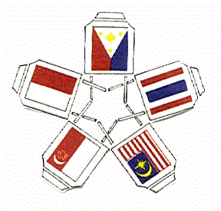

**Asean Federation of Electrical**

**Engineering Contractors (AFEEC)**



**Member:**